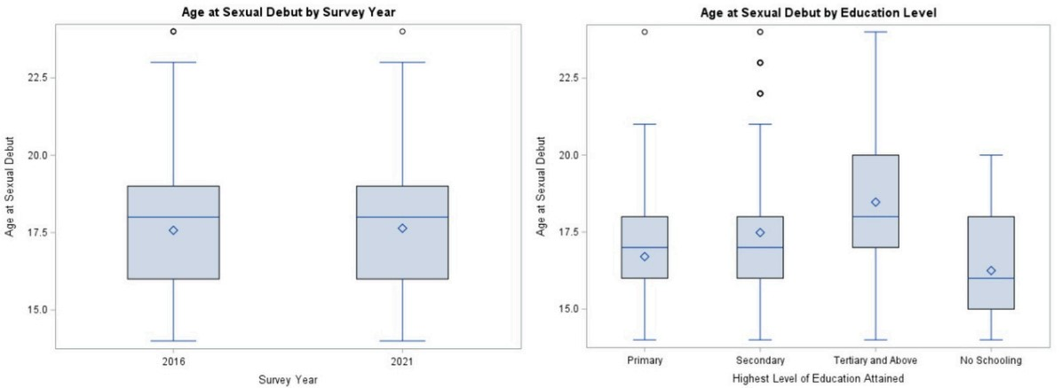
Figure 1. Mean Age at Sexual Debut Among Sexually Active Adolescent Girls and Young Women (AGYW) in Eswatini, by Survey Year and Educational Attainment
Significant differences by highest level of education attained (p < 0.0001); no significant difference by survey year (p = 0.7194)

